MSS GRADE 10 Course Selection Instructions for 2024/25
- Google MyEducationBC login (aspen)
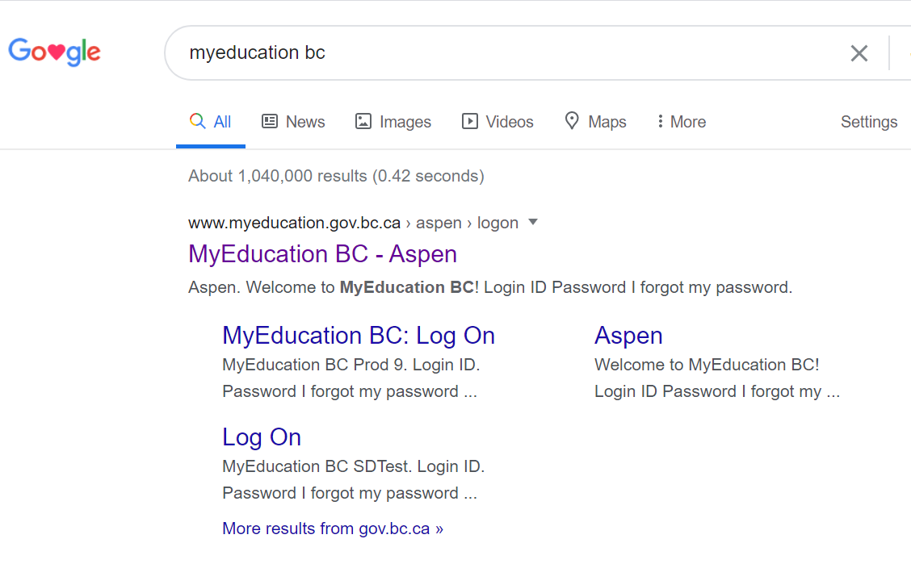
Click on this one!
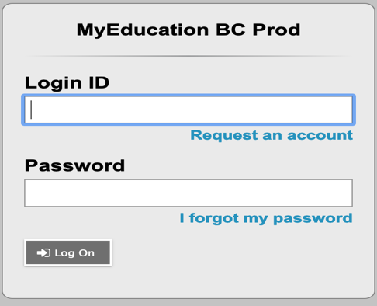
Very Important that it has this title!

- Login ID is your Student # (the one you use to log into the computers at school)

Temporary Password - Winter$2024 (make sure W is capitalized)

- Make a new password.
DO NOT use your name or your birthday!
The new password MUST have a capital letter, a lowercase letter, a symbol, and a number.
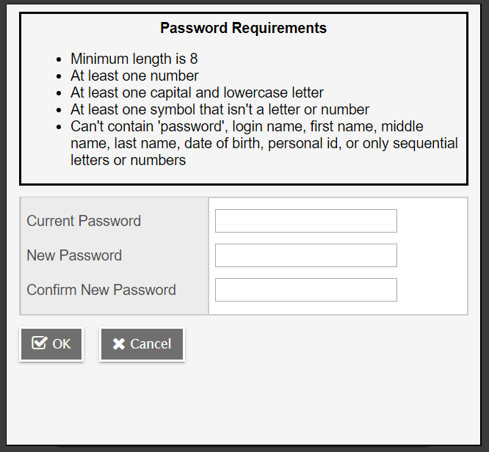
Use an activity or hobby. For example: Football#1.
NOTE: You only have 3 tries to log in before you are locked out so, please be very careful that you are logging in correctly. IF you are locked out, the secretary at your school can do a reset.
- Enter information in the Security Preferences Update.

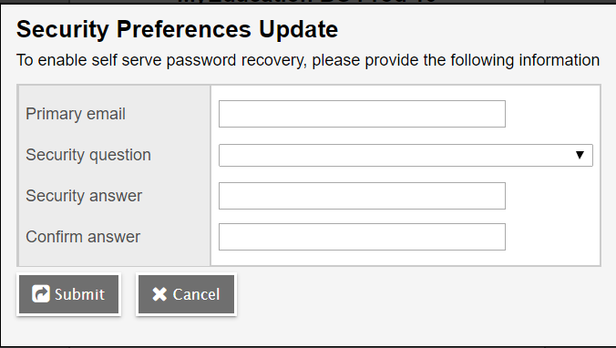

- Once you have changed your password. Go to the MY Info (top left of the screen)
Here

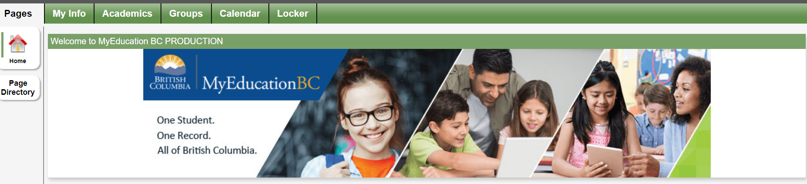

- Click and scroll down to Requests on left side of screen.

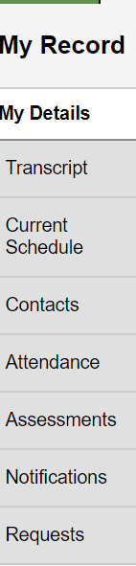
Here

- Make your primary request(s). Some classes are required. Use side arrows to go to next page.
NOTE: If you are planning to go to a post-secondary institution, you may need a second language at the Grade 11 level, but it is not required.

For OUTSIDE timetable classes (Leadership, Band, Football….) select that page.

Make your alternate choice(s). This is IMPORTANT. If you have no alternates, we choose for you!

Please look for the PRIORITY column, where you can enter a number value for each choice and alternate (rank order).

- Enter notes for counsellor. For example: I feel that I need a Learning Support Block.

- Click on POST at the bottom on the left. WAIT until you get a green checkmark!

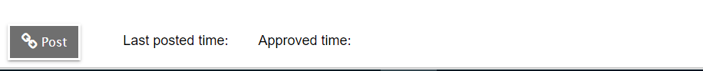
- You have made your course selection(s). Please log out.
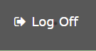 Top Right Corner of the screen.

