How to log into the online Data Base for Research

Step 1) Go to the Mission Public School
- website: www.mpsd.ca
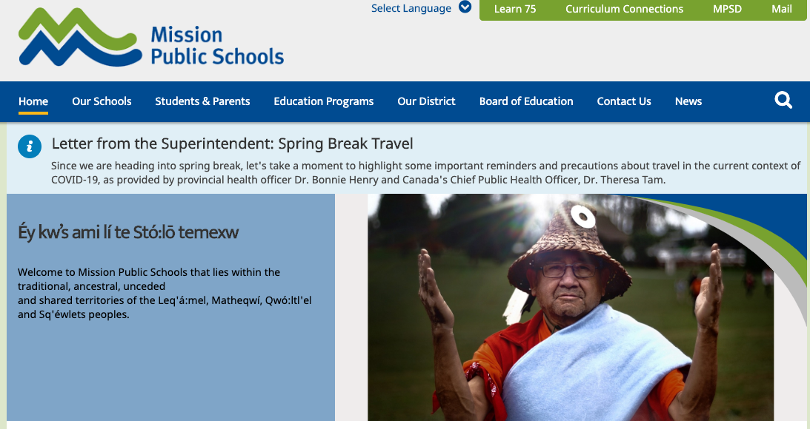
Step 2) Click on Learn 75 at the top of the page

Step 3) Click on ERAC BC Digital Classroom
-if you need a username: mss_erac password: mss
-make sure it’s mss underscore erac
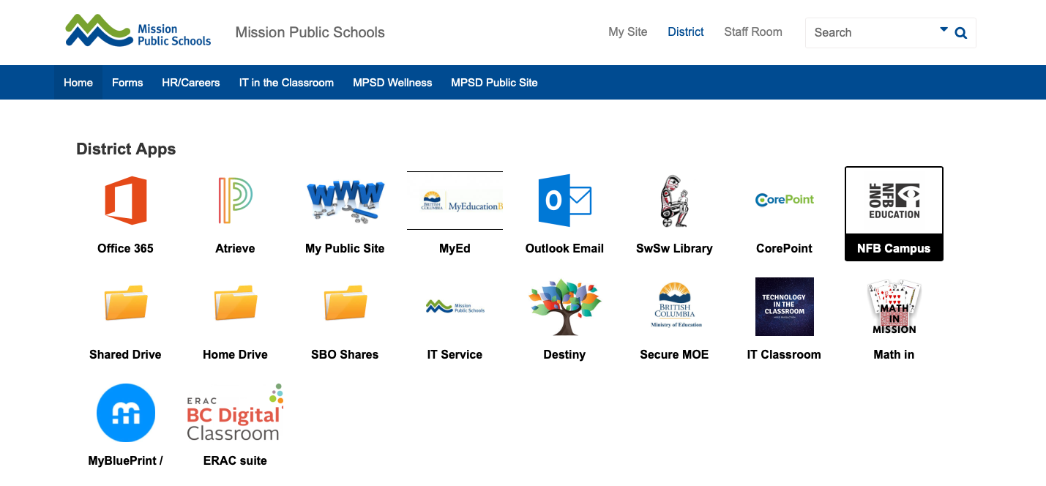

Step 4) Scroll Down to See all the Apps
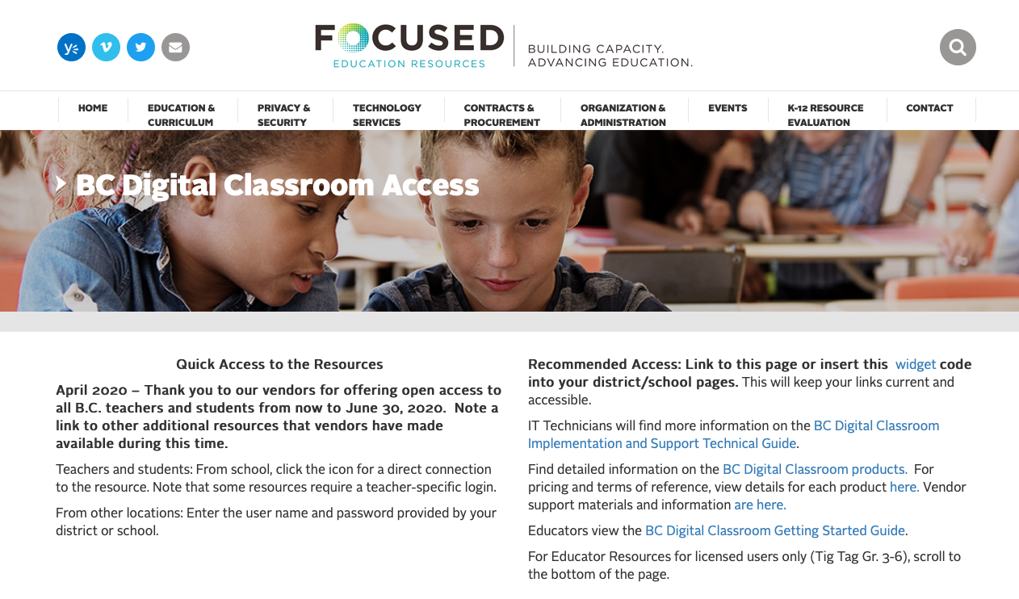

Step 5) You can use Consumer Health Complete, Science in Context, or the World Book Advance to complete your research. Check out Teen Magazines too.

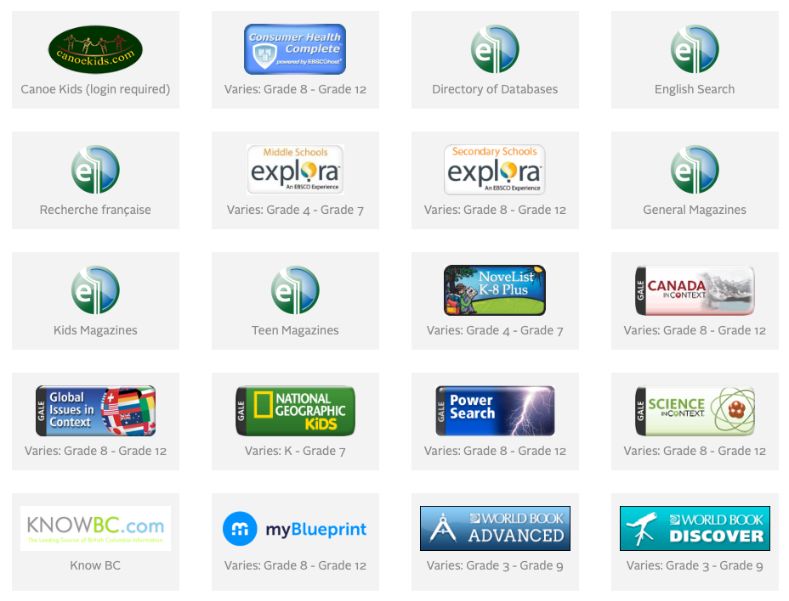

Scroll down further to see how to use each resource.

World Book Advanced
Step 1) Type in your topic– CHECK YOUR SPELLING
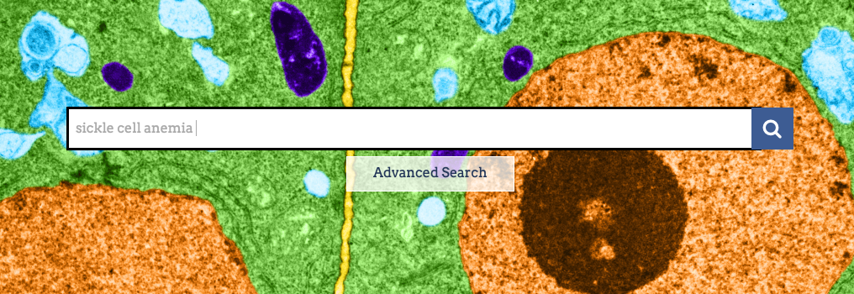

Step 2) Click on the name of the article to access it
-Remember notes are in point form.
- Remember to copy and paste the source citation at the bottom of the article for your bibliography.
