Good News! Yearbook signing IS NOT cancelled!
Mission Senior Secondary Parents and Students:
Yearbook Signing: SOCIALLY DISTANCED EDITION
We are excited to announce that the Mission Senior Secondaary yearbook signing tradition is alive and it’s fully digital to suit our socially distanced students.

Jostens has just launched a new platform, Yearbook Digital Signing Pages, that gives every student in our school the chance to create virtual signing pages, invite their friends to leave messages, and print out the final pages to keep with the yearbook as a permanent keepsake. This is free for every student whether they purchased a yearbook or not.

Share the link below with your student so they can get started with their yearbook signing.
yearbooksigning.jostens.com

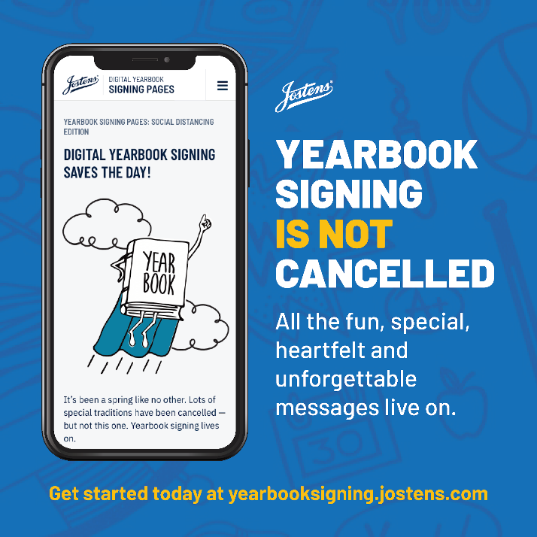
A few things to note:
• Choose “Other” as the province
• Remind students to sign their name and move their signature to an empty space in the book.
• Share the url with only people they trust and want to sign their books. Sharing via social media means through messenger.
• Best to use Chrome.

